6A^{th} Grade: Unit 1, Lesson 2

- The first few multiples of 2 and 7 are plotted on the number lines. What is the first number that is a multiple of both 2 and 7?
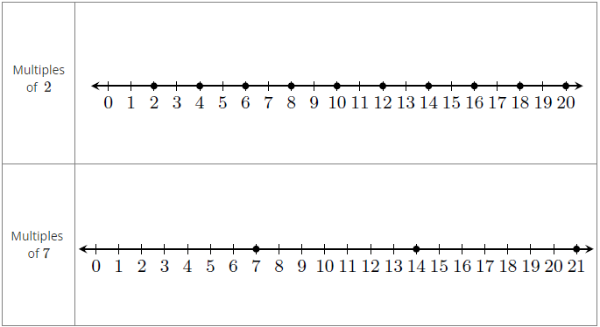

14

- What is the least common multiple of 6 and 8?

24

- What are the multiples of 9?

9, 18, 27, 36, 45, 54…

